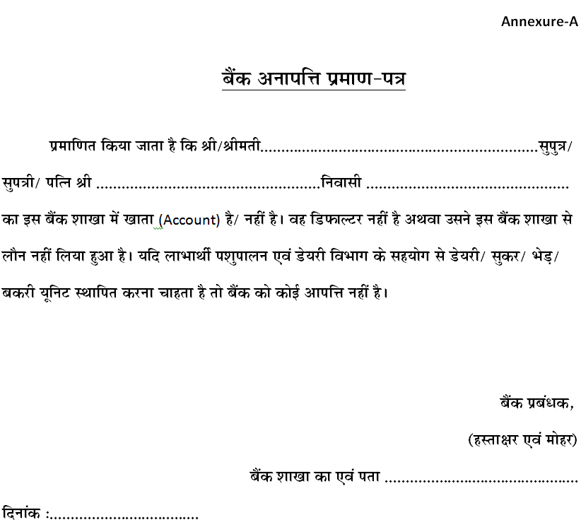

Annexure-VI

NO OBJECTION CERTIFICATE FROM BANK

It is hereby certified that, Sh./ Smt S/o/D/o/W/o Sh…………………............................................................. S/o/D/o/W/o Sh. ......................................................................................... resident of ............................................... having/ not having bank account in this branch. He/ She is not defaulter or has not taken loan from this Bank. This bank has no objection, if the beneficiary wants to establish a dairy unit with the help of Animal Husbandry & Dairying Department.

Dated:
Bank Manager,
(Signature & Stamp)
Name of Branch

